FOLLOW UP REFUSAL
[Administrator]
[School]
Dear [Administrator]
As I have advised you previously, I have elected not to subject my [child/children], [names of children] to the 2015 STAAR assessments. I have not requested your permission; I have informed you of my decision. I make this decision as the parent of [names of children] in their best interests. I do not agree with the system of high stakes standardized assessment and am particularly concerned about the emotional and physical damage these assessments cause to the children participating in them. Because of this risk of harm to my [child/children], we refuse to participate. I do not give the school permission to administer these assessments to my children. My children have been instructed that if they are presented an assessment, they are not to complete it or otherwise participate. I am certain that [Name of School District] ISD will not in any way instruct my [child/children] to engage in conduct that their parent has strictly forbidden. To do so would be a most egregious invasion of the parent-child relationship, and one that is not in any manner privileged.
We can disagree about whether Sec. 26.010 of the Education Code applies to STAAR or not. The legislature distinguishes clearly between tests and assessments and is clear the STAAR is an assessment. But regardless of our views on this subject, there are four points that are incontrovertible:
- The school’s obligation to assess its students is satisfied by offering them the opportunity to be assessed;
- There is no means to physically compel a student to complete assessment;
- The TEA has given schools instructions on precisely what to do with the assessment when a student refuses to complete it ; and
- As of last year, the TEA has authorized the submission of blank assessments for scoring based on nothing more than parental notice. In person refusal by the student was not required.

I attach excerpts indicating that the TEA clearly contemplates that students may refuse assessment and how the school is to process the refusal. Given these simple facts, I am sure we can all agree that there is no benefit to either the school or a family that has a moral objection to STAAR to creating a dramatic event or test of wills over the administration of a single student. For that reason, I acknowledge the school’s position that it cannot grant my opt out request, though I disagree and refuse assessment on behalf my child. Please confirm that based on my refusal, you will submit a blank answer sheet for scoring on behalf of my child.
I will confirm submission of the scoring sheet after the first day of assessment so that we may return to school. Thank you for your attention to this matter.
Sincerely,

[Name of Parent]

TEA Frequently Asked Questions About Test Administration
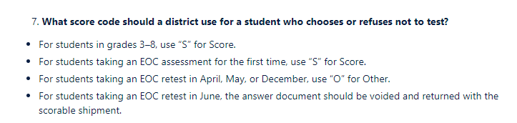
https://txassessmentdocs.atlassian.net/wiki/spaces/ODCCM/pages/2547989336/Frequently+Asked+Questions+About+Test+Administrations
Campus and District Coordinators Manual
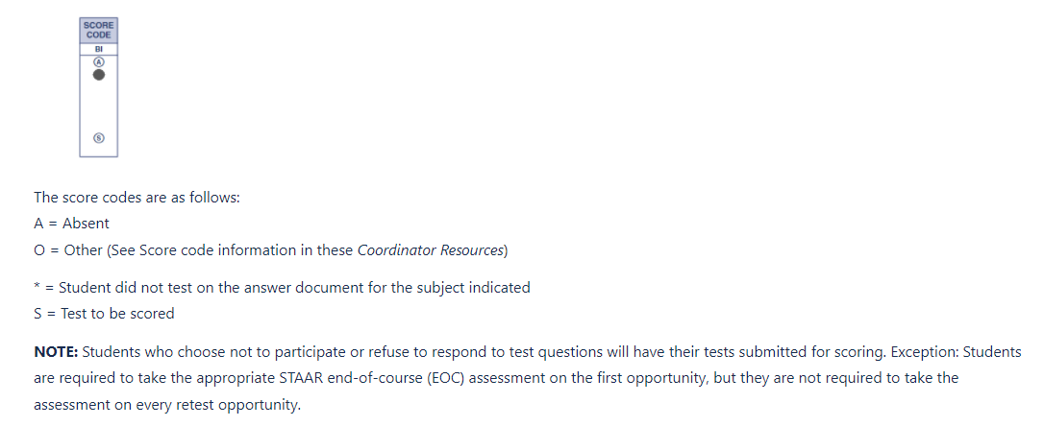
https://txassessmentdocs.atlassian.net/wiki/spaces/ODCCM/pages/2547986514/Prepare+answer+documents
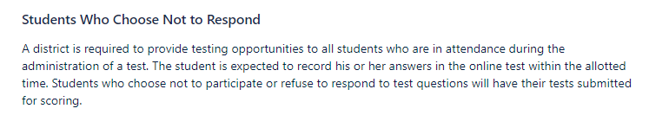
https://txassessmentdocs.atlassian.net/wiki/spaces/ODCCM/pages/2547989159/Online+testing+procedures

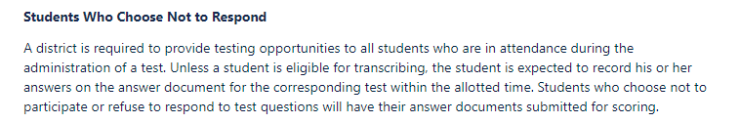
https://txassessmentdocs.atlassian.net/wiki/spaces/ODCCM/pages/2547986453/Paper+testing+procedures

